**Checkpoint Design your application**

* **User Story:**

**As an admin you can :**

Manage students ( add , delete , update , mark attendance )

Manage teachers (add , delete , update , mark attendance , assign subjects)

Manage parents ( add , delete , update )

Manage classes and subjects

Manage admission requests

Chat with users

**As a student you can :**

View your grades

View your teachers

Manage your subjects

View homework

Chat with admin and teachers

**As a teacher you can :**

Manage your subject ( homework , tests )

Manage your students

Chat with other users

Manage student attendance and grades

**As a parent you can :**

View your children status

Chat with teachers and admin

View your children homework , attendance and grades

* **Use case diagram:**

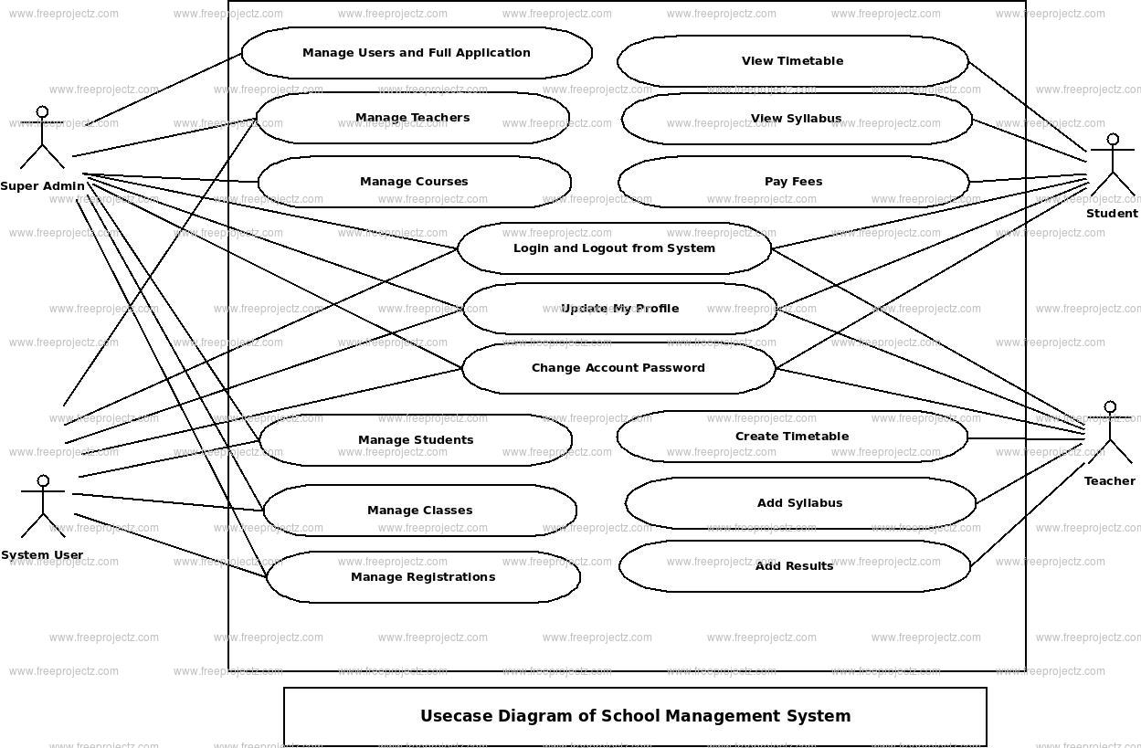

* **Classes diagram:**

